Lab 13-1 Modeling a Dimension Extension Table
Goals | To model a dimension extension table.
Scenario | ABC wants to show price category as an additional customer dimension attribute. It is stored on a physical extension table.
Outcome | In the Physical layer, a Customer2x table.  In the Business Model and Mapping layer, a modified Customers logical table.  In the Presentation layer, a modified Customers presentation table.
Time | 5 – 10 minutes
Environment | 
Instructions:
- Examine the structure of the physical tables that store the customer data. The main customer information is in D1_customer2; the extension attributes are in Customer2x.
  - Select Start > Programs > Microsoft SQL Server > Enterprise Manager to use the Microsoft database utility to view the tables.
  - Expand the entries in the left pane to expose the Databases.
  - Expand the SupplierExtend database and click Tables to view the tables in the database.
  - Right-click D1_customer2 and select Open Table > Return Top.
  - Enter 10 and click OK.
  - Right-click Customer2x and select Open Table > Return Top.
  - Enter 10 and click OK.
  - How do the tables relate? What is the primary/foreign key relationship?
  - Leave Enterprise Manager open because you will use it during the testing below.
- Open the repository.
  - Shut down the Siebel Analytics Server service.
  - Double-click C:\SiebelAnalytics\Repository\abc.rpd. Log in as Administrator with no password.
- Create the physical source in the repository that points to the extension table.
  - Select File > Import > from Database.
  - Select ABCEXTEND and click OK.
  - Expand and select Customer2x.
  - Click Import.
  - Click Close.
  - Drag Customer2x from within dbo in ABCEXTEND to dbo in ABC and delete ABCEXTEND.
- Create the physical joins using the physical diagram.
  - In the Physical layer, select Customer2x, D1_customer2, and D1_Orders2 and click the Physical Diagram icon in the toolbar.
  - Use the new foreign key icon to construct the joins. The extension table should be on the one side. Click Yes to create the key prompts.
Extension column | Main column
Customer2x.Custkey | D1_customer2.NewKey
Customer2x.Custkey | D1_Orders2.CustKey
  - Verify the physical joins:
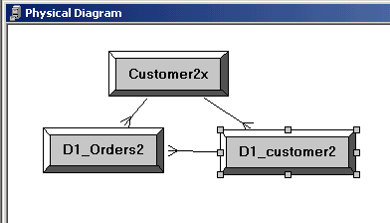
  - Close the Physical Diagram.
- Add a separate logical table source for the extension to the logical dimension table.
  - In the Business Model and Mapping layer, expand Customers.
  - Right-click Sources and select New Logical Table Source.
  - In Name, type Customer Extension.
  - Click Add.
  - Select Customer2x.
  - Click Select.
  - Click OK.
- Add the logical columns from the extension table.
  - In the Physical Layer, expand Customer2x.
  - Drag PriceCategory onto Customers in the Business Model and Mapping layer.
  - Drag Custkey from the Physical layer onto CustomerKey in the Business Model and Mapping layer.
- Add the extension column to the Presentation layer by dragging PriceCategory to SupplierSales.Customers.
- Select File > Check Global Consistency to validate your work.
- Select File > Save to save your work.
- Select File > Exit to close the Administration Tool.
- Test your results.
  - Start the Siebel Analytics Server service and restart the Siebel Analytics Web service.
  - Start Siebel Analytics Web and log in as Administrator with no password.
  - Click the Answers link.
  - Click the SupplierSales subject area.
  - Run a request to display Customers.Customer and Customers.PriceCategory:
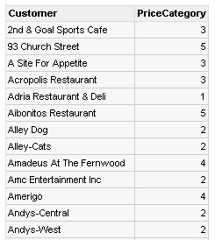
  - Compare the result in Siebel Answers with the result in Enterprise Manager.
    - Return to Enterprise Manager.
    - In the D1_customer2 window, click the SQL icon.
    - Enter where Name = ’93 Church Street’ and click ! to run.
    - What is the NewKey value for 93 Church Street?
    - In the Customer2x window, what is the PriceCategory associated with Custkey 1004?
    - In Answers, verify the Price Category for 93 Church Street is 5.
- View the SQL used to produce the result.
  - Double-click C:\SiebelAnalytics\Log\NQQuery.log.
  - Scroll to the end of the file and then backwards to locate the select statement:
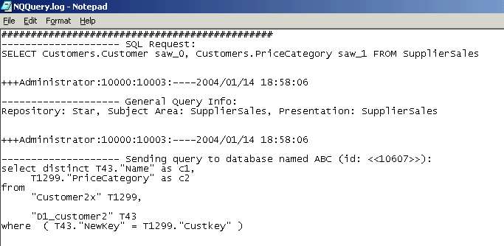
  - Why is the SQL accessing both the main and extension table?
- Validate that the SQL is optimal.
  - Return to Answers and remove the PriceCategory from the Criteria and rerun the query.
  - Close and open the log file and inspect the select statement:
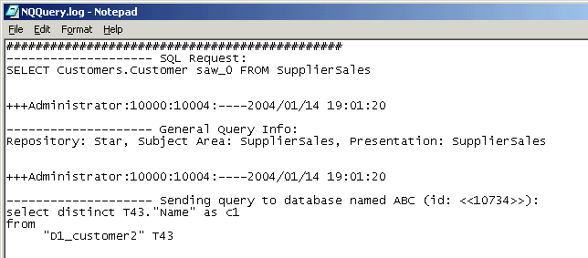
  - Why isn’t the extension table in the query?
  - Return to Answers and remove the column.
  - Query for Customers.PriceCategory, SalesFacts.Dollars.
  - Close and open the log file and inspect the select statement.
    - Which tables are used in the query, and why?
  - Select File > Exit to close the file.
  - Select File > Close to exit Answers.
Leave Enterprise Manager open for the next lab.
Solutions 13-1 Modeling a Dimension Extension Table
Answers
1.h. How do the tables relate? What is the primary/foreign key relationship?
The Custkey column in Customer2x is the foreign key to the primary key, NewKey column in the D1_customer2 table.
11.f.iv. What is the NewKey value for 93 Church Street?
1004
11.f.v. In the Customer2x window, what is the PriceCategory associated with Custkey 1004?
5
12.c. Why is the SQL accessing both the main and extension table?
The request from answers asked for Price Category, which is on the extension table, and Customer Name, which is on the main table.
13.c. Why isn’t the extension table in the query?
Because no data was requested from the extension table, and the way we modeled the extension will not force a join unless data is necessary.
13.f.i. Which tables are used in the query, and why?
PriceCategory comes from the extension table Customer2x. D1_customer2 is joined to the extension table and main table D1_Orders2. Dollars comes from the main table D1_Orders2.
Lab 13-2 Modeling a Fact Extension Table
Goals | To model a fact extension table.
Scenario | ABC wants to show credits as an additional order measure (fact). It is stored on a physical extension table.
Outcome | In the Physical layer, d1_Orders2X.  In the Business Model and Mapping layer, modified SalesFacts.  In the Presentation model layer, modified SalesFacts (includes Credits).
Time | 10 – 20 minutes
Instructions:
- Examine the structure of the physical fact tables for order. The main order information is in D1_Orders2, the extension attributes are in d1_Orders2X.
  - Return to Enterprise Manager.
  - Right-click D1_Orders2 and select Open Table > Return Top.
  - Enter 10 and click OK.
  - Right-click d1_Orders2X and select Open Table > Return Top.
  - Enter 10 and click OK.
  - How do the tables relate? What is the primary/foreign key relationship?
  - Close Enterprise Manager.
- Open the repository.
  - Shut down the Siebel Analytics Server service.
  - Double-click C:\SiebelAnalytics\Repository\abc.rpd. Log in as Administrator with no password.
- Create the physical source in the repository that points to the extension table.
  - Select File > Import > from Database.
  - Select ABCEXTEND and click OK.
  - Expand and select d1_Orders2X.
  - Click Import.
  - Click Close.
  - Drag d1_Orders2X from within dbo in ABCEXTEND to dbo in ABC and delete ABCEXTEND.
- Add the ROW_WID column that stores the line item information to the orders table in the Physical layer.
Note: The ROW_WID column stores the line item information on the D1_Orders2 table on the SupplierExtend database. Since the ABC database object in the Physical layer is now accessing the SupplierExtend database, you can add this column to the D1_Orders table.
  - Double-click D1_Orders2.
  - Click the Columns tab and click New.
  - In the Name field, enter ROW_WID.
  - In the Type field, select INT from the menu.
  - Click OK to close the Physical Column dialog box.
  - Click OK to close the Properties window.
- Create the physical joins using the physical diagram.
  - In the Physical layer, select d1_Orders2x and D1_Orders2 and click the Physical Diagram icon.
  - Use the New Foreign Key icon to construct the join. The extension table should be on the one side. Click Yes to create the key prompts.
Extension column | Main column
d1_Orders2X.ROW_WID | D1_Orders2.ROW_WID
  - Verify the physical join:
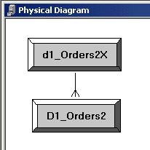
- Add the extension table to the existing source for the facts.
  - In the Business Model and Mapping layer, expand SalesFacts and Sources.
  - Double-click D1_Orders2.
  - Select the General tab.
  - Click Add.
  - Select d1_Orders2X and click Select.
Note: In ABC’s case, every order has a row in the extension so a join type of Inner is appropriate. You would adjust this to Left Outer if rows might not be in the extension table.
  - Verify your work:
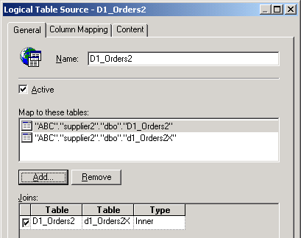
  - Click OK.
- Add the logical columns from the extension table.
  - In the Physical Layer, expand D1_Orders2X.
  - Drag CMDolrs onto SalesFacts in the Business Model and Mapping layer.
  - Rename CMDolrs to Credits.
  - Double-click Credits.
  - Select the Aggregation tab.
  - Select Sum.
  - Click OK.
  - In the Physical Layer, drag ROW_WID from d1_Orders2X onto SalesFacts in the Business Model and Mapping layer.
  - Verify your work:
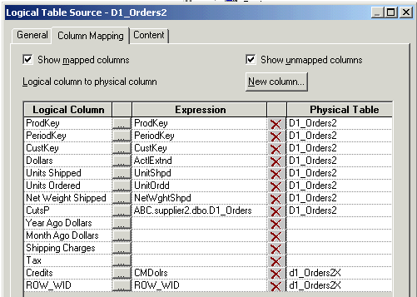
- Add the extension column to the Presentation layer by dragging Credits from the Business Model and Mapping layer onto SalesFacts in SupplierSales in the Presentation layer.
- Select File > Check Global Consistency to validate your work.
- Select File > Save to save your work.
- Select File > Exit to close the Administration Tool.
- Test your results.
  - Start the Siebel Analytics Server service and restart the Siebel Analytics Web service.
  - Start Siebel Analytics Web and log in as Administrator with no password.
  - Click the Answers link.
  - Click the SupplierSales subject area.
  - Run a query for data from both the main and extension tables by selecting Customers.Customer, SalesFacts.Dollars, and SalesFacts.Credits, and click Results:
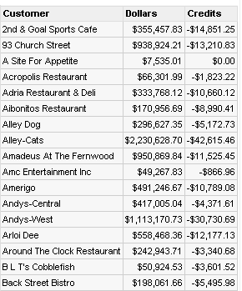
- View the SQL used to produce the result.
  - Double-click C:\SiebelAnalytics\Log\NQQuery.log.
  - Scroll to the end of the file and then backwards to locate the select statements:
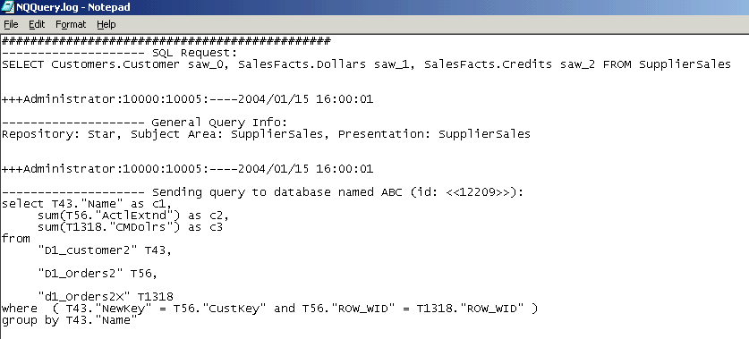
  - Verify that the D1_Orders2 (main table) and the d1_Orders2X (extension table) are both referenced.
- Validate that the SQL is optimal.
  - Return to Answers.
  - Run a query for data from only the main table by selecting Customers.Customer and SalesFacts.Dollars and clicking Results.
  - Close and open the log file and inspect the select statement. Verify that the extension table is not referenced in the query:
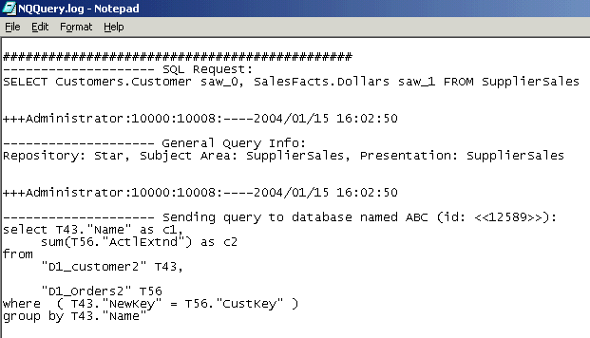
  - Return to Answers.
  - Remove all columns from your query.
  - Query for Periods.Month, SalesFacts.Credits.
  - Close and open the log file and inspect the select statement.
  - Why was the main fact table accessed even though no data was requested from it?
  - Why didn’t you model the extension table as a separate source?
- Select File > Exit to close the log file.
- Select File > Close to close Siebel Answers.

Solutions 13-2 Modeling a Fact Extension Table
Answers
1.f. How do the tables relate? What is the primary/foreign key relationship?
The extension table relates to the main table via ROW_WID.
14.h. Why was the main fact table accessed even though no data was requested from it?
The only way to access the dimension is through the main fact table. There is no join from the extension to the dimensions.
14.i. Why didn’t you model the extension table as a separate source?
There are no foreign keys on the extension to the dimension tables. The extension needs to go through the main table to get to the dimension data.

